**Pre-Lab 6:**

**Diodes**

Name: Wan-Yu Liao

ECEN 325 Section 514

TA: Mandela

Date: October 11, 2019

**Calculation**

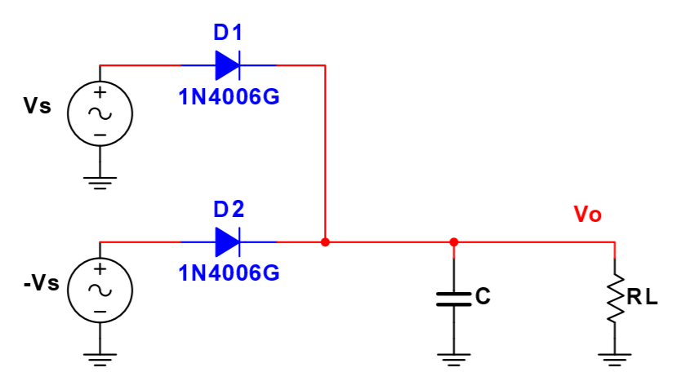



**Simulations**

**(1)**

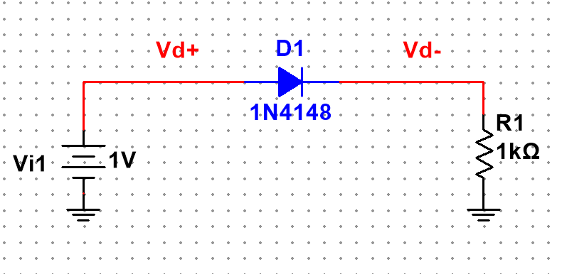

Figure 1: Schematic for Fig. 2(a) ▲

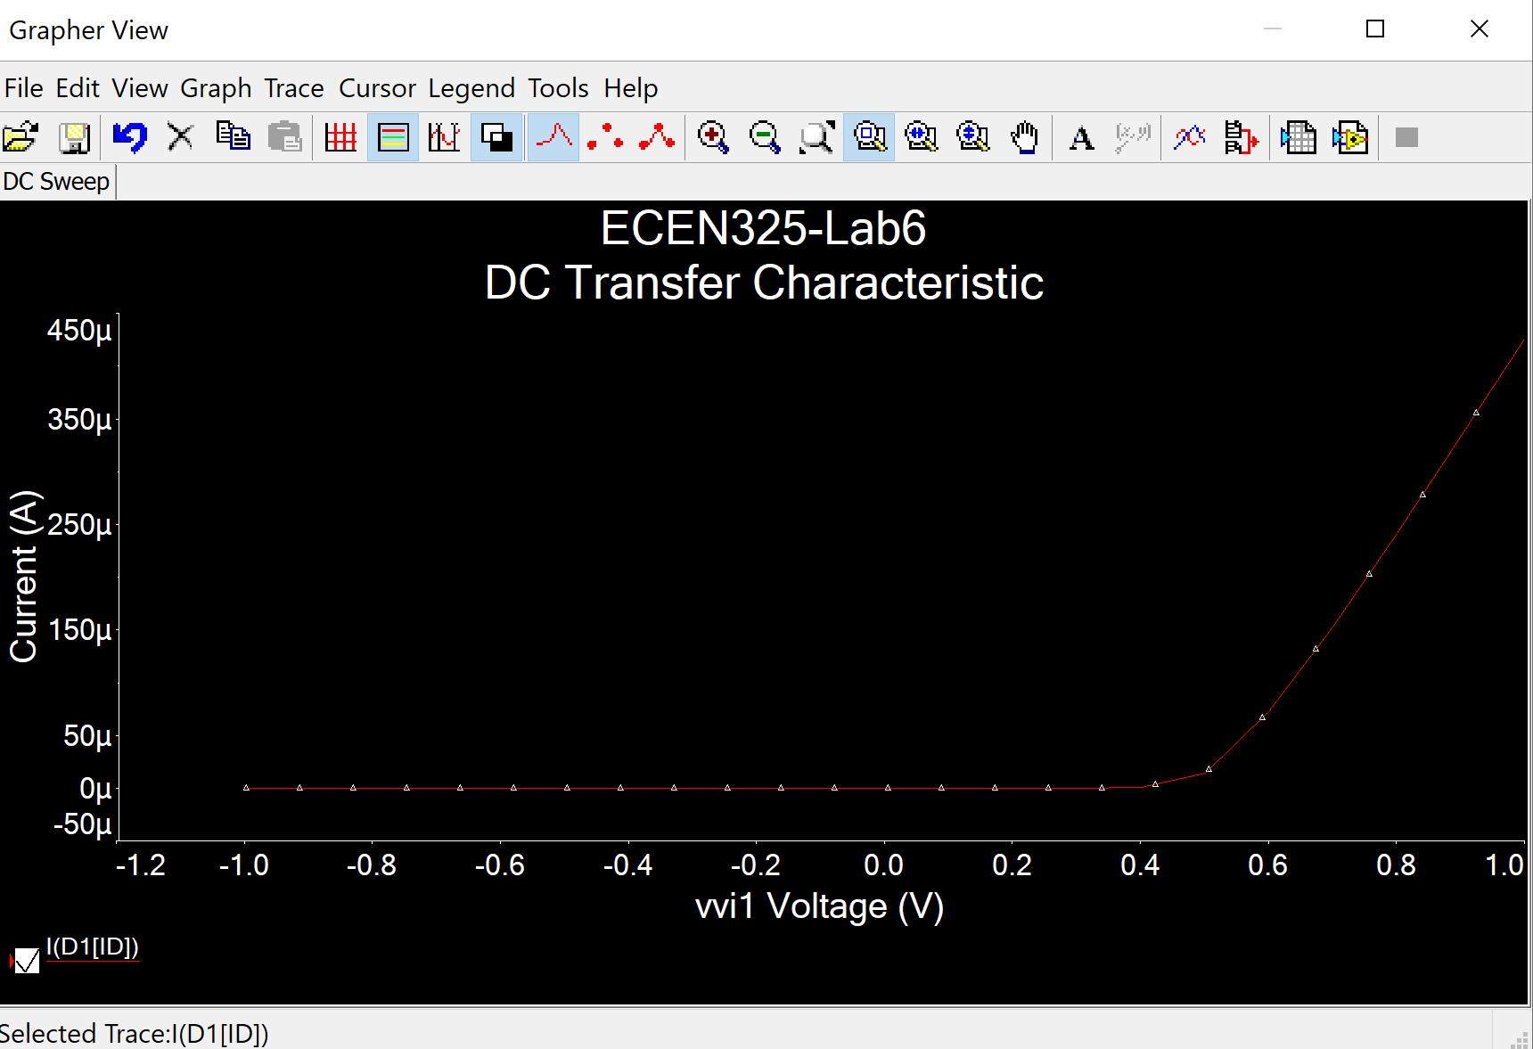

Figure 2: DC sweep simulation plot for Fig. 2(a) where Vstep = 0.1 from -1 V to 1 V▲

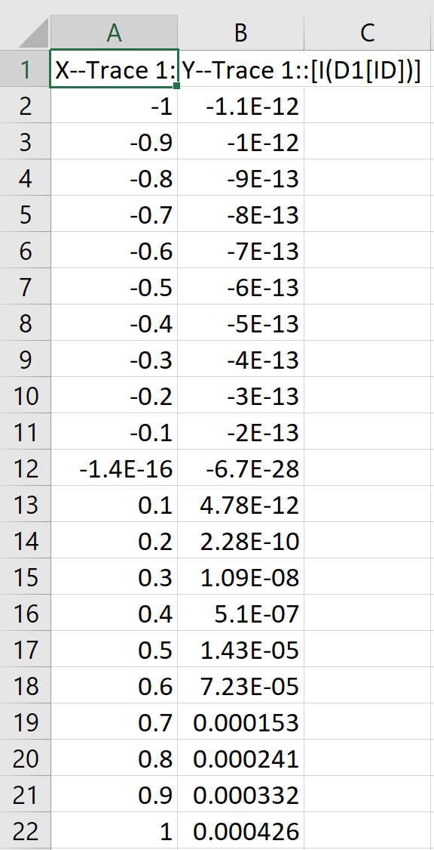

Figure 3: Simulation data for Fig. 2(a) ▲

Figure 4: Excel data plot for Fig. 2(a) where Vstep = 0.1 from -1 V to 1 V ▲

(2)

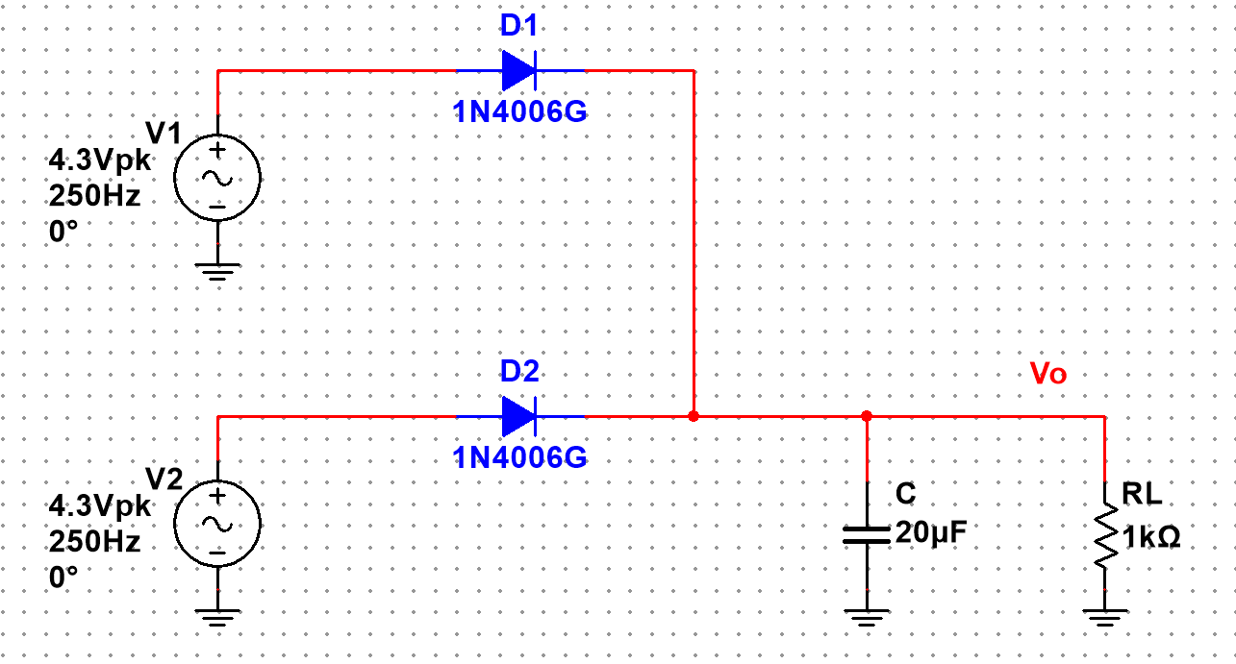

Figure 5: Schematic for Fig. 5 with calculated values▲

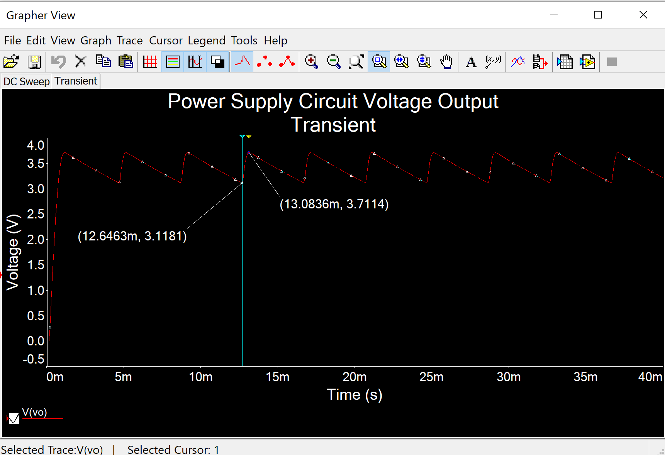

Figure 6: Power supply circuit transient simulation for voltage output▲

Voltage high peak = 3.7114 V, Voltage low peak = 3.1181 V, Max ripple = 0.5933 V

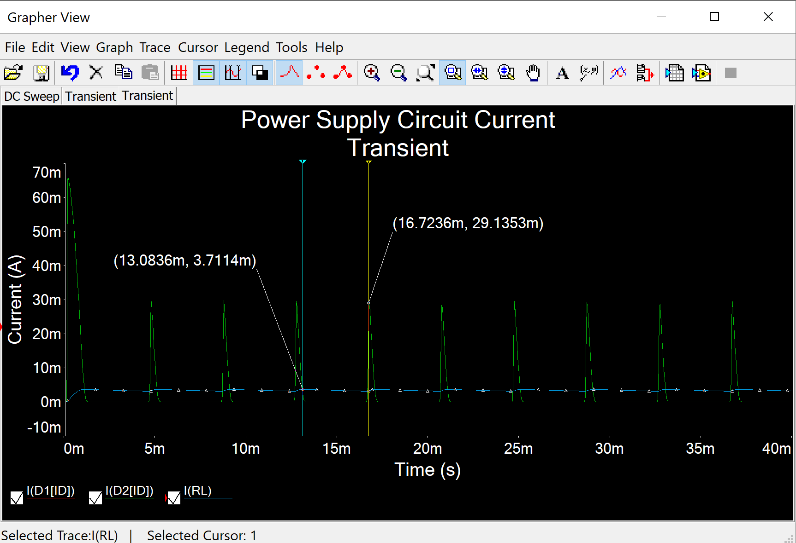

Figure 7: Power supply circuit transient simulation for currents ▲

Peak current on diodes = 29.1353 mA for both D1 and D2

Peak current on load resistor = 3.7114 mA